Problem 2 Efficient Frontier

Suppose you have the choice of investing in the three assets from the last homework with the following statistics:

Expected Returns
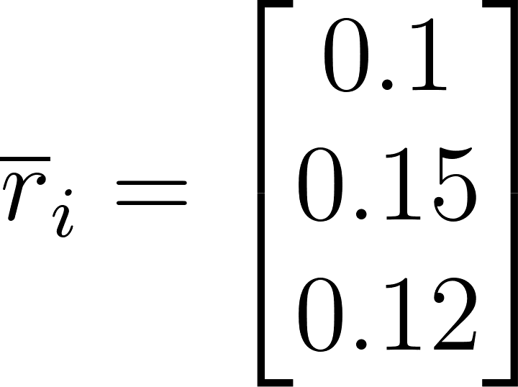
Standard Déviations
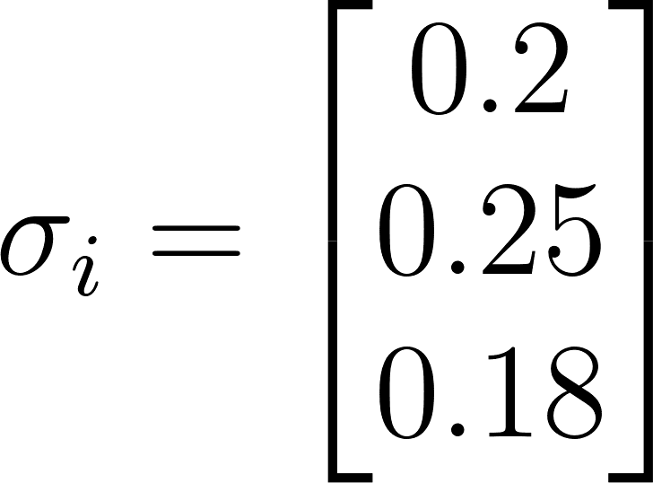
Correlations
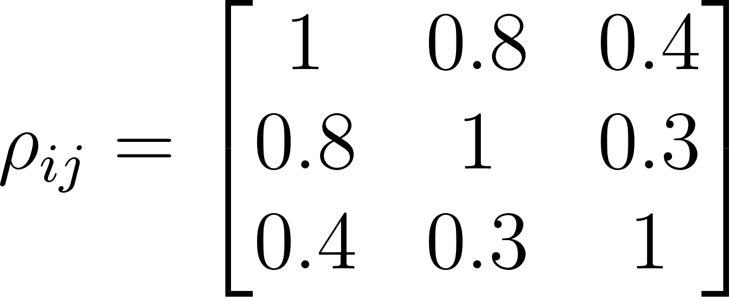

Plot 1000 random portfolios from last time that will make up the space of feasible solutions. Upload your code in MATLAB, Python, etc… that does the following steps:
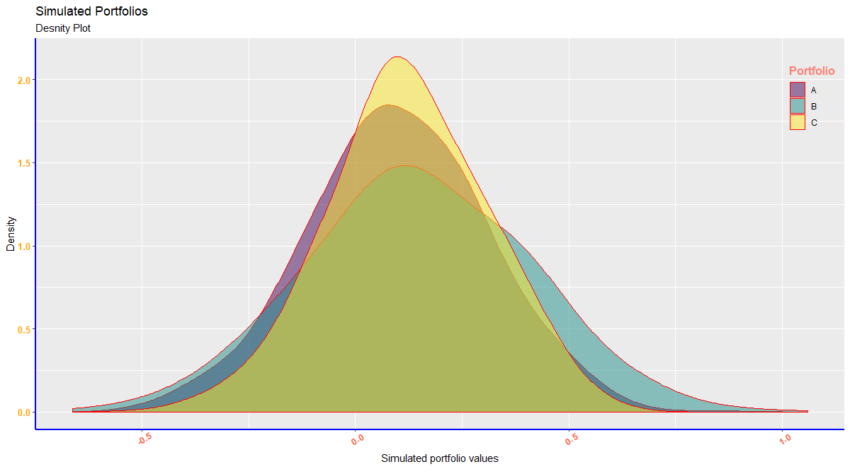
- Find the Efficient Frontier using the KKT conditions.
Given the maximum variance, the efficient frontier is 0.00514
- Plot the Efficient Frontier on the background of the 1000 random portfolios from last time.
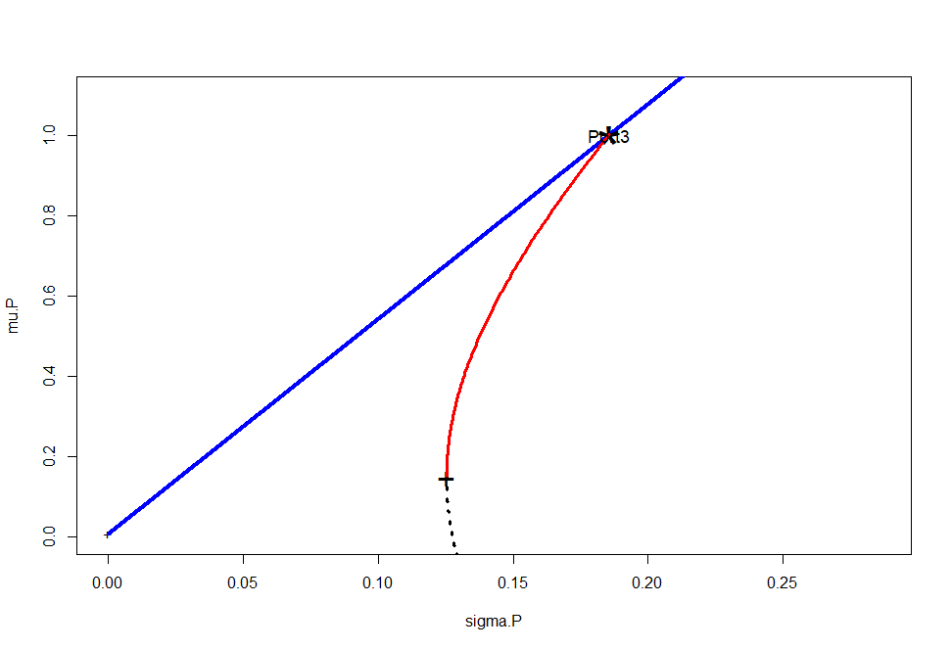
e) Comment on the location of the efficient frontier from a) as compared to that from b) that you see emerging from this graph.

The efficient frontier lies closely at the maxima of portfolio 3 where the variance is maximum.

